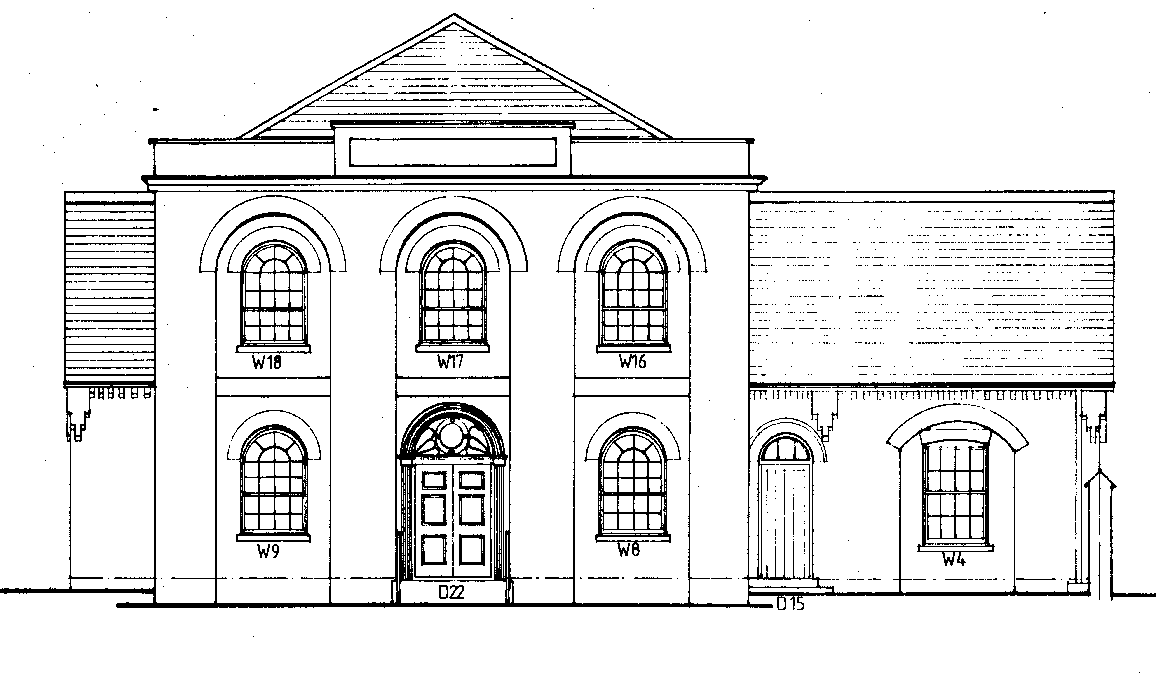

Thruxton Memorial Hall

Policy for the Safeguarding of Children, Young People
and Adults at Risk

A copy of this policy should be kept in the Hall at all times
and appended to Hiring Agreements where necessary.

Thruxton Memorial Hall aims to provide a safe and secure venue for a range of services, activities and events. The Trustees recognise the importance of ensuring the safeguarding and welfare of all users of the Hall.

This policy is made available to all adults who use the Hall for any activity, including those who run events or activities on behalf of the Trustees. In most cases children will be accompanied by an adult (a parent or carer) who will take responsibility for them. Young people, (defined as secondary school age or above for the purposes of this policy) may possibly attend on their own.

Adults at Risk (defined as any adult who may be at risk of abuse or neglect due to the actions ((or lack of action)) of another person) may attend activities independently and may need additional protection accordingly.

This policy includes Child and Adult Protection Procedures, Recruitment and Whistle Blowing. Safeguarding policies are subject to annual review and the procedures are updated as and when necessary, (ie when regulations or recommendations change or in the light of any case reviews).

1. Safeguarding Policy

This statement of policy and procedures applies to users of and activities in the Thruxton Memorial Hall.

The purpose of this policy is to:

1.1 Protect children and young people who receive services or attend activities at Thruxton Memorial Hall.

1.2 Protect adults at risk who receive services or attend activities at Thruxton Memorial Hall

1.3 Provide the Trustees, event and activity organisers, staff and volunteers with the overarching principals that guide our approach to Safeguarding and Child Protection.

The Trustees are committed to ensure that robust safeguards are in place, that policies and procedures are current and fit for purpose and that complaints and referrals are investigated and handled promptly, efficiently, sensitively and without fear or favour.

Enquiries about the operation of this policy may be made in the first instance to Kate Christie, Chair of the Hall Trustees. (Kate.christie7@me.com or telephone 0773 6804445).

2 Procedures for Safeguarding

2.1 Groups and individuals hiring the Hall are responsible for their own safeguarding arrangements. The Hall’s responsibility is to ensure that anyone who runs events or activities specifically for Children, Young people or include any adults who may be at risk maintain the required levels of disclosure, supervision and have appropriate training. Organisers of activities attended by vulnerable persons must have appropriate measures in place to ensure sufficient protection is afforded to those persons. Organisers of such activities must disclose those measures to the Trustees upon request. Use of Thruxton Memorial Hall may be refused where adequate protection for such vulnerable groups cannot be demonstrated to the Trustee’s reasonable satisfaction.

2.2 Groups which serve the under 3, 3-5, and 5-11 age groups should follow the Ofsted guidelines for levels of supervision.

https://www.gov.uk/government/publication/ofsted-safeguarding-policy

2.3 If any user of the Hall has concerns about the behaviour or actions of anyone associated with the Hall, they should immediately inform the named person in their group initially responsible for Safeguarding and/or Kate Christie, Chair of Trustees (Kate.christie7@me.com tel 07736 804445). Anyone acting in an unsafe or unwise manner may be subject to referral to the relevant authorities.

2.4 Any concern disclosed to a user or hirer should be recorded by said user or hirer and also the Trustees as soon as practicable.

Leading questions should not be asked but a clear factual written record made of what has been disclosed. All referrers should follow the following summary guidance:

- Record the date and time of both the incident and the complaint
- Don’t promise to keep what you have been told a secret
- Tell the child, young or adult at risk what you will do next
- Don’t make promises you can’t keep

2.5 All disclosures should be immediately reported to the named Safeguarding person for the hiring group who should as soon as possible inform the responsible Trustee (see 2.3 above)

2.6 Confidentiality cannot be promised in any case where an individual may be in danger from any form of abuse. Abuse can include physical, sexual, emotional or neglect. The Trustees may, without reference to any person, seek assistance or make a referral to any competent authority for them to advise or take appropriate further action, with the adult responsible for the individual who has made a disclosure being notified if appropriate.

2.7 Persons making relevant disclosures to the Trustees of Thruxton Memorial Hall must co-operate fully with the Hall and any competent authority in dealing with investigations into complaints, must follow appropriate recommendations and carry out any recommended further actions.

3. Recruitment and Selection of Contracted Staff and Volunteers.

Currently, the Hall has no such persons, however, the following policy instructions will apply should this change. It should be noted also, that should an individual or organisation be hiring the Hall in any capacity that regularly involves children, a DBS certificate will be required as part of their agreement to hire the hall for said purpose.

Any future staff or contracted volunteers will have their role assessed and any necessary checks carried out accordingly.

https://www.gov.uk/dbs-check-applicant-criminal-record

4. Whistle Blowing Policy

4.1 The Trustees will, under this Whistle Blowing Policy, protect any individual making a referral. Should the individual making the referral feel that insufficient action/follow up has taken place, they should inform the Chair of the Trustees without fear of repercussion. (see note 2.3)

4.2 Procedures for Whistle Blowing include; protecting those who make referrals under this policy so that there is a culture of informing without reprisal or negative consequence.

4.3 As far as is possible protecting the anonymity of the whistle blower, (except where so doing could endanger another individual).

4.4 Keeping accurate records.

Further advice and support can be gained from the following sources

Child Protection NSPCC – www.nspcc.org.uk 0116 234 7223
NSPCC Child Protection Helpline 0808 800 5000 – www.disclosure.gov.uk
Criminal Records Bureau. – www.disclosure.gov.uk
Save the Children – www.scfuk.org.uk
Early Year Partnership – based in County Social Services Dept
Vulnerable Adults Protection: Action on Elder Abuse – 0808 808 814

